

MY XL-ENZ  
Sales order entry

Documentation

# PREFACE

This documentation and the software described in it are copyrighted with all rights reserved. Under copyright laws, this documentation and the software may not be copied in whole or in part, without the written consent of Reflecta Automation BV. Under the law, copy includes translating into another language or format.

The information contained in this documentation is subject to change without notice. Although efforts have been made to ensure the accuracy of the documentation, Reflecta Automation BV assumes no liability for damages incurred directly or indirectly from errors, omissions, or discrepancies between the software and the documentation.

This manual is meant for users of XL-ENZ. Basic knowledge of XL-ENZ is assumed. This specifically applies to the usage of the toolbars.

The following conventions are used in this manual:

|  |  |  |
| --- | --- | --- |
| Convention | Explanation | Example |
| **BOLD** | A user interface component, such as a menu option or the name of a program or a button. | Click on **Start**. |
| *Italic* | A reference to the name of a field or a variable. | At *article type* you can choose for … |
| Courier | Path of the menu | Articles | Basic articles | Articles |
| Vertical bar | Separator for path of the menu |  |
| Square brackets | Indication for a tab | Under the tab [General] you can … |

If the documentation is unclear or you encounter problems concerning the functionality, you can e mail to the helpdesk (supportxl@reflecta.nl).

We assume that this module contributes to a pleasant and successful usage of XL ENZ.

**© Reflecta Automation BV**

CONTENTS

PREFACE 1

1 INTRODUCTION 3

2 MASTER DATA 4

2.1 Delivery terms sales 4

2.2 Sales man (customer service) 4

2.3 Order types 4

2.4 Order origins 5

2.5 Carriers 6

2.6 Sales cancel reasons 6

2.7 Sales departments 7

2.8 Blocking reasons customers 7

2.9 Hold shipment reasons 8

2.10 Link customer sales man/sales representative 8

2.11 Delivery terms per customer 9

2.12 Default carrier 9

2.13 Freight charges 10

2.14 Handling charges 11

2.15 Delivery priority 12

2.16 Delivery scenarios 12

2.17 Customer hold shipment reason 13

3 GENERAL 14

4 SALES ORDER HEADER 17

5 SALES ORDER LINE 21

6 CHANGE ORDER 24

7 SPECIFIC FUNCTIONALITIES 25

7.1 Freight charges and handling cost charges 25

7.2 Generate delivery slips 25

7.3 Copy order lines 28

7.4 Generate sales order from purchase order 30

7.5 Global update earliest delivery date 31

7.6 Cancellation of Order Line(s) (sizes) 32

8 CUSTOMER SERVICE COCKPIT 33

|  |  |  |  |  |
| --- | --- | --- | --- | --- |
| Version | | | | |
| **Version** | **Date** | **Paragraph** | **Adjustment** | **Author** |
| 2.0 | 20 April 2012 | All | Translation from Dutch | Bert Schilt |
| 2.1 | 13 August 2012 | Sales order line | Determine sales price | Bert Schilt |
| 2.2 | 3 September 2015 | 2 | Master data | Bert Schilt |
| 2.3 | 4 July 2016 | All | Several adjustments | Bert Schilt |

# INTRODUCTION

My XL-ENZ is a set of basic documentation to start working with XL-ENZ. It consists of the elementary subjects necessary to begin working with the application. My XL-ENZ is divided into a number of segments. Together these contain the main components of the application. Beside that there is separate documentation available for the additional modules to XL-ENZ.

With My XL-ENZ the documentation will be presented to you in Word format. We supply this in that standard format, so you can personalize this. You can add your own screen prints or add text to make the documentation specific for the working methods in your organization.

# MASTER DATA

## Delivery terms sales

Menu path: Sales | Master Data Sales | Delivery Terms Maintenance

Via the delivery terms you can indicate whether freight charges need to be calculated. For giving a description you need to consider that applying the freight charges depends on an amount so this could be either ‘not free house’ or ‘free house’.

By marking *Charge Delivery Costs* you indicate that freight charges can be calculated when the freight table is filled. Whether freight charges will be actually calculated, depends of the order amount and the amounts in the table.

The indication *Add Remarks* means that you get the option to add an additional tekst (30 positions) in the sales order at the delivery term concerned. This is mostly used to enter the harbour. The delivery term is than eg ‘FOB’ and the additional remark is than ‘Shanghai’.

## Sales man (customer service)

Menu path: Sales | Master Data Sales | Sales Man Maintenance

This concerns the persons who enter the sales orders. You need to register at least one sales man code.

## Order types

Menu path: Sales | Master Data Sales | Order Types Maintenance

This is for type setting a sales order. You need to register at least one order type. Per order type you can indicate whether positive or negative quantities may be entered (*Positive and Negative Value Acceptance*). You could define a separate order type for entering negative sales orders (returns). That can be practical for analysis. Via the order type you can optionally book sales and cost prices to separate general ledger accounts.

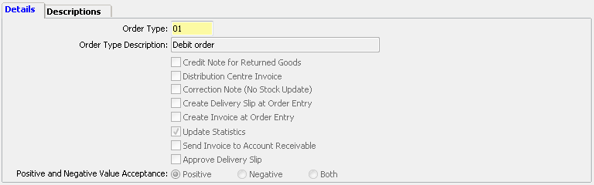

The order type is also used for specific usage in modules. This concerns returns (indicator *Credit Note for Returned Goods*) and distribution center (indicator *Distribution Centre Invoice*). These functionalities are explained further in the documentation of these modules.

With *Correction Note (No Stock Update)* you indicate that the order is a (price) correction on a previous order. The specific effect is that no stock update will follow from the order. We advise to always make a separate order type for this option. You should also mark the indication *Create* *Delivery Slip at Order Entry*. Otherwise it cannot be invoiced.

There can be situations where the order should be put up for invoicing immediately. For this there is the indication *Create* *Delivery Slip at Order Entry*. It is better to make a separate order type for this. A sales order will be registered as delivery (delivery slip) immediately (and the stock is lowered). This is also called ‘counter sales’. This is a.o. also used for invoicing services.

The option *Create Invoice at Order Entry* is in fact only applicable for a distribution center.

With the indication *Update Statistics* you indicate whether the sales statistics need to be updated for the order type concerned. Be aware that you may want to use the statistics for a check with the financial administration. When the statistics are not updated equally, you will not have a reconciliation.

The indication *Send Invoice to Account Receivable* can eg be used for an order type for B2C orders. These accounts receivable often have already received an invoice or settlement via the website. This specifically concerns sending invoices via mail. When you have registered for the (B2C) customer that the invoices should be printed, the (B2C) invoices will be printed. The thought behind this is that it may be desired to have a physical invoice document for the administration. For these (B2C) customers/accounts receivable you can indicate that no output should be generated for the sales invoice.

## Order origins

Menu path: Sales | Master Data Sales | Order Origin Maintenance

Via order origins you can group sales orders. This is used for statistical purposes. There are also steering parameters linked to this code. The most global grouping is for ‘presales’ and ‘direct sales’. At *Order Definition* you can indicate whether it is a *Direct Sales* or a *Pre Sales* or *Other*. At this moment this is only used for data exchange with external applications or customizations.

The indication *Track Order Amount per Sales Season* is for a credit limit check on orders. That can be specifically applicable for presales. The indication means that an order will be blocked automatically when the order exceeds the credit limit for the sales order season. The order must be cleared separately. This is an extra credit limit check next to the check that takes place via the delivery proposal. Therefore this check is more applicable to presales.

Per order origin you can indicate which stock you wish to see at sales order entry. You can indicate that on the tab [Stock Control Field]. But first you need to link order types on the tab [Use with Order Types]. This way you can show a different stock per order type. For a counter sale that could eg be the free physical stock and or a regular (debit) order the available stock. Choosing for showing the stock is only applicable when you do not work with the module ATP. Under ATP fixed stock information is shown.

The order types you can link via the tab [Use with Order Types] is only applicable in combination with showing the stock information (see above). Each order type can be used with an order origin.

## Carriers

Menu path: Sales | Master Data Sales | Carrier Maintenance

You can define a carrier as part of entering the relations. You can also do this via a separate program. When you indicate there that the carrier should also become a relation, the carrier concerned will be added to the relation table on saving. Take care of the sequence of registration. When the carrier should also be an account payable, you need to register that via the relation program.

This table is used for both sales and purchases. We advise to also create a code for ‘own transport’ (this does not need to be registered as relation). Registration of a carrier is mainly important for generating shipping labels. That falls under a module.

Your customer number at your carrier you need to register per company. This can vary per company.

## Sales cancel reasons

Menu path: Sales | Master Data Sales | Sales Cancel Reason Maintenance

This code is used for cancelling sales order lines. Entering a cancellation code is mandatory for cancelling order lines. Be aware that there also default cancellation codes need to be filled under **Sales Default Cancellation Reasons** [menu: System Management | System Management Sales]. This is applicable for some specific situations, like cancellation of quantities when less is delivered on a delivery and the customer does not want backorders.

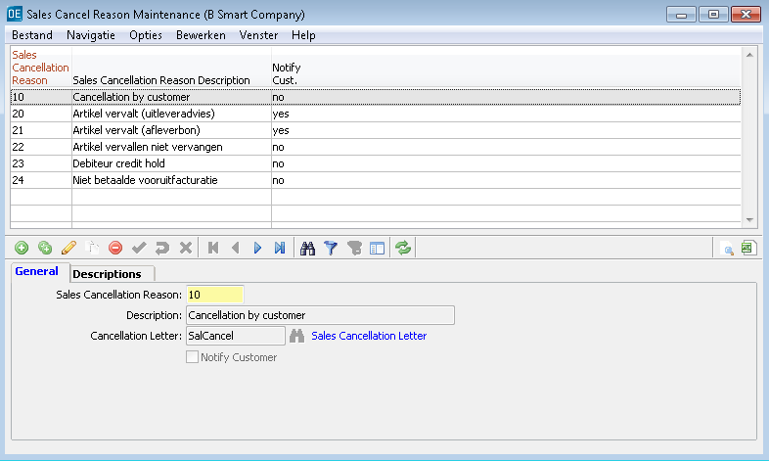

There is an option to link a letter to a cancellation reason. The letters must of course be defined first (see master data relations). The indication *Notify Customer* is connected to this. You can indicate whether the order lines for this specific cancellation reason should be included on a letter to a customer.

## Sales departments

Menu path: Sales | Master Data Sales | Sales Department Maintenance

When there are different sales departments in your company, of which each eg handles a separate group of items, you can define sales departments. Per department you can indicate which product lines are sold via the department. Items that do not fall under these product lines cannot be entered in the sales order under the department concerned. You need to define at least one sales department to be able to enter sales orders.

## Blocking reasons customers

Menu path: Sales | Master Data Sales | Customer Blocking Reason Maintenance

You can block customers for delivery. For that the system will ask for a blocking code, which indicates the reason for the block.

## Hold shipment reasons

Menu path: Sales | Master Data Sales | Hold Shipment Reason Maintenance

You can block a delivery slip for shipment. For that the system will ask for a blocking code, which indicates the reason for the block. The indication *Staging Delivery* means that the delivery slips will get a separate indication. This is mainly used for the situation that goods are packed up front and will be delivered on a later moment.

## Link customer sales man/sales representative

Menu path: Sales | Link Master Data | Customer (internal) Sales Rep. Maintenance

At relations you register sales representatives. At master data sales you register codes for sales man (customer service). With this table you can link sales representatives to customers. This is only applicable when there can be more than one sales representative per customer. When a customer always has one sales representative, you can enter that at the master data of the customer.

With the link table it is possible to link a sales representative (and a sales man) to a group of customers. That can eg be depend on a brand. The sales representative will be linked to the sales order line and be registered in the sales statistics on invoicing. When the sales representative and the sales man form a team in your company, you can link these both. When that is not the case, you can leave the code for sales man empty.

You can link sales representatives (and sales men) on several levels. You can also work via ‘exceptions’. You can eg link a sales representative to a group of customers and next give a different sales representative to a specific customer from that group. On sales order entry you have the option to enter a sales representative (in the order header); the table will then not be applicable (!).

BE AWARE: On registering the links something specific is applicable for the combination between customer and brand. When you create a record with a representative for a specific customer and next an ‘exception’, where a sales representative is linked to the combination customer/brand for the same customer, the system will use the sales representative of the customer and not the one for the brand. This will only be done when you create records per customer/brand. Only customer is considered more specific than customer/brand. It is possible to organize this via the product line.

When the system notices at sales order entry that no sales representative is linked to a customer, order entry will not be allowed. The system will give a message. You could prevent this by defining a ‘general’ sales representative in the link table. Be aware that the order will be registered on that sales representative.

It is possible that you have defined multiple combinations. Via the tab [Filter] you can filter on specific combinations (eg based on sales representative).

When you make changes in the table which need to be applied in open sales orders, you can apply this via a special icon in the toolbar (). Be aware that this can take some time. You can also apply this when all changes have been made.

## Delivery terms per customer

Menu path: Sales | Link Master Data | Delivery Terms per Customer

Here you register the default delivery term. Via this table the delivery term is filled for the sales order. Here you can also link a delivery term to a customer, a country or an order origin. When you leave these empty, this is considered a ‘default delivery term’ (see screen shot). This will be applied at sales order entry. When you do not define a (default) delivery term, you need to fill the delivery term for each sales order.

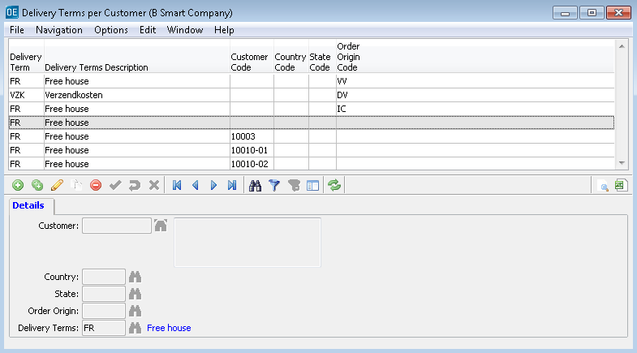

## Default carrier

Menu path: Sales | Link Master Data | Default Carrier Maintenance

Here you can indicate who is the default carrier. Via this table the carrier is linked automatically to the delivery slip on delivery. You can eg also register the carrier per customer, country, warehouse or transportation mode.

When you have not linked a (default) carrier, then it is not possible to generate a delivery proposal. When you define a carrier and optionally a carrier product and leave the other fields blank, this is considered a ‘default carrier’ which will be applicable for all shipments (see screenshot). You can change the carrier on confirming the delivery slips.

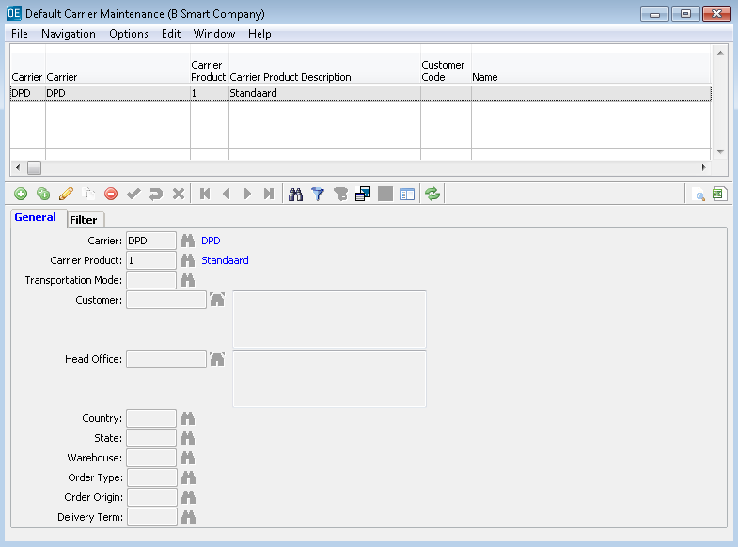

## Freight charges

Menu path: Sales | Link Master Data | Freight Charges Maintenance

Here you can register the freight charges and indicate on which criteria this will be applicable. For registering freight charges in this table, you need to have created an item for freight charges. That item must be defined as type ‘service’.

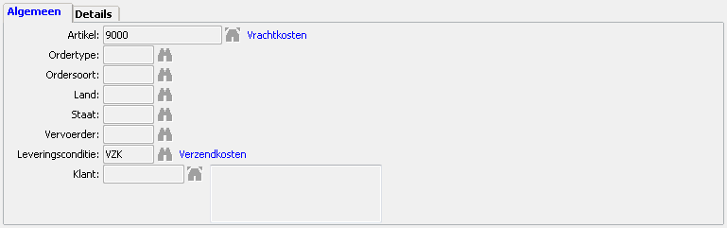

The country concerns the country of the delivery address.

On the tab [Details] you need to define the amount or the percentage of the freight charges. When you do not do that, the table will not be applicable.

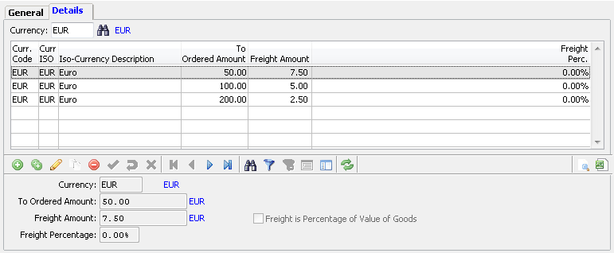

On the tab [Details] you first need to choose a currency. Then you can define rules for the freight charges to be calculated. That is mostly based on a certain minimum amount. The freight charges are only calculated based on order amount. The freight charges can be an amount or a percentage. The freight charges are calculated per sales order. Be aware that the freight charges are only calculated when under the delivery term (in the order header) is indicated that freight charges should be calculated.

## Handling charges

Menu path: Sales | Link Master Data | Handling Charges Maintenance

The table for handling charges works the same as for freight charges (see previous). Handling charges can only be calculated when at customer level is indicated that handling charges must be calculated.

## Delivery priority

Menu path: Sales | Link Master Data | Delivery Priority Maintenance

You can work with delivery priorities. On defining you can indicate on which criteria this will be applicable. The delivery priorities are applicable in the delivery proposal when the priority is included in a delivery scenario. You can eg give a lower priority to customers and/or accounts receivable with a blocking reason (eg for payment issues).

We advise to define a ‘default priority’ for all customers when you want to use priorities (see screenshot).

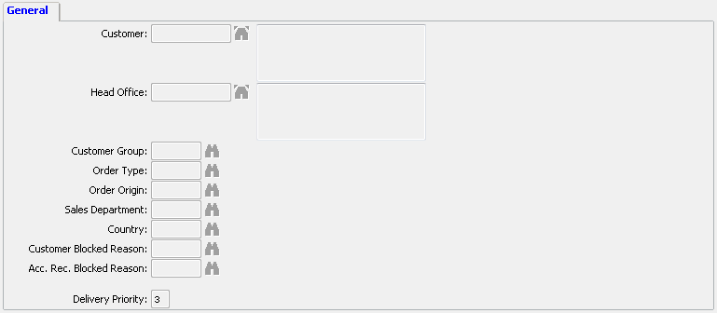

## Delivery scenarios

Menu path: Sales | Link Master Data | Delivery Scenario Maintenance

Menu path: Sales | Link Master Data | Delivery Scenario Item Link Maintenance

The delivery proposal will take delivery scenarios into consideration, where the scenario determines the sequence of delivery. Furthermore the delivery scenario is important for the module ATP. When you do not define a delivery scenario and/or do not link items, the delivery will be ‘random’.

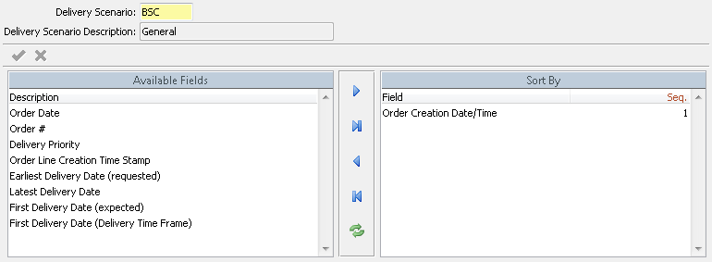

You can define multiple scenarios. On linking items (see next) you can indicate which scenario is applicable. Per scenario you can select multiple criteria and indicate the sequence of these. The most detailed is *Order Line Creation Time Stamp*. The creation time stamp (on order level or on order line level) is the only option that cannot be influenced by the user.

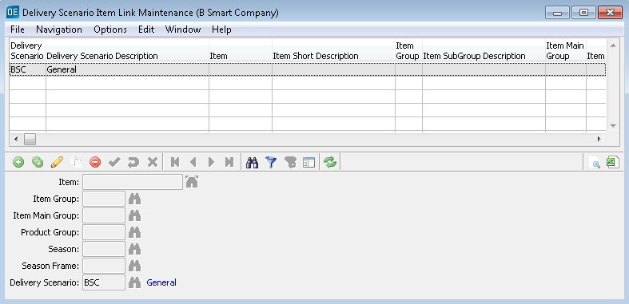

When a delivery scenario is applicable to all items, you need to create a record for which you do not enter any other value (see screen shot). For specific situations you can define exceptions.

## Customer hold shipment reason

Menu path: Sales | Link Master Data | Customer Hold Shipment Reason

Via this program you can give customers a hold shipment reason. This will be applied automatically on generating delivery slips for these customers.

# GENERAL

Menu path: Sales | Sales Basics | Sales Order Entry

**User defaults**

Before a user enters his/her first sales order, it is important that he/she fills in his/her personal ‘default values’. These fields can be found under the tab [User Defaults]. On the first order entry these values can be entered without entering an order first.

Purpose of the user defaults is that the sales order header can be filled in automatically as much as possible. This specifically applies to the mandatory fields. A number of fields are filled from the master data of the account receivable. Other data can be filled with the user defaults. This speeds up the sales order entry. The user defaults are specific for the user. It is practical to close the order entry program after you entered or changed the user defaults. On entering a new order, the user defaults will be applied to the order header.

Because the user defaults are per user, each user can fill his/her name as sales man (*Handled by*). This will be filled in for each order the user enters.

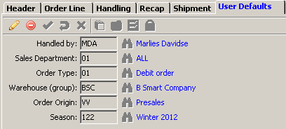

**Order numbering**

Orders are numbered consecutively automatically. The number is given on saving the order header. The start number is defined in the implementation data. You can also enter a number manually. The order number must be unique.

**Order types**

The order type is a very important component of the order entry. Amongst others it indicates if it concerns a debit order or a credit note. Via the order type you can also register a counter sales (order).

The order types are registered as master data of the sales. In general several order types are defined. The following features can be set:

* You indicate that only positive quantities can be entered or also negative quantities.
* You indicate if the stock must be updated (eg. consider price corrections).
* You indicate if the actual stock must be updated directly (the so-called counter sales).

It is important the the user knows the difference between these order types. Once an order type is chosen, it cannot be changed after entry of the order lines. Wrong usage can have big consequences for the way the sales order is processed in the application.

**Order origin**

The order origin is a.o. important for statistical information. But the order origin is also used to determine which stock will be shown on entry of the order line. This is indicated in the master data of the order origin.

**Release record**

If you are entering (or updating) an order, an icon will be activated in the toolbar (). This means that the order is held for you. In a decentralized environment as XL‑ENZ it would otherwise be possible that another user will also retrieve your order and generates an action on it (eg. compile a delivery slip). As long as you are working on the order, it is best to keep the icon active. After starting a new order, the previous order will be automatically be ‘freed’. Your new order will be held at that moment.

You can release an order if you are finished with the order entry and not yet continue with another order, but want to keep the present order on the screen to check. As long as you do not release the order, no other user can get to that order.

**Tables**

In the order header there are a few tables, from which the values will be generated by default, unless you overwrite these manually in the order header. This concerns freight charges, handling cost charges, early delivery allowance, commission, representative and carrier. If you let the system determine the values, these will NOT be shown in the order header. These will be determined by the system on a later moment (at generating the delivery slips or at invoicing).

**Save**

Before you can continue with entering the order lines, you need to save the order header. If that is not done, you cannot enter an order line; the toolbar will be inactive.

**TIP: quick order entry**

You can speed up the entry of an order by pressing **TAB** and **F2** after creating a new order (+) and entering the customer number. Of course you need to be certain that the default values generated automatically by the system in the order header are correct.

# SALES ORDER HEADER

**Default values**

After entering the customer number several values will be filled automatically in the order header. A part of this data comes from the master data of the account receivable. Another part comes from the user defaults (see previous chapter). The delivery condition comes from a separate table. All mandatory fields (marked red) can be filled automatically this way. By letting the system fill these fields automatically, you can speed up the order entry.

Of course you can still adjust this data. This specifically applies to that order. For the next order the same default values will be retrieved from the different master data sources.

**Tab [General]**

Below the specific functionality of some of the fields from the order header is described as far as these need further explanation. Order type and order origin are explained in a previous chapter.

* Warehouse (group) – This comes from the user defaults. The order is placed on the warehouse entered and will also be delivered from that warehouse.
* Order Origin
* Currency – This comes from the master data of the account receivable.
* Mode of Payment – This comes from the master data of the account receivable. This indicates the manner of payment. This is specifically important if eg. the shipment is COD or payment will be done via a purchase association.
* Payment Terms – This comes from the master data of the account receivable.
* Delivery Terms – If you want to charge freight charges, you need to choose a delivery term for which you have indicated in the master data that freight charges will be applicable. Furthermore a freight charge table needs to be filled in. You can check the freight charges or update these on the tab [Recap] in the order header.
* Transaction Type – This comes from the master data of the account receivable. This is an important field to determine whether VAT should be calculated or if it concerns an intercommunity delivery. If the wrong transaction type is chosen, this can lead to wrong (VAT) declarations.
* Handled by – This comes from the user defaults.
* Sales Season – This comes from the user defaults.
* Customer Reference – Here you can enter free text, divided over two fields. Optionally you can print this text on a delivery slip or on an invoice.
* Early Delivery Allowance – This comes from the master data of the customer and is by default not filled in, because it will be retrieved on generating the delivery proposal. If you want to overwrite this, you need to mark the indicator *Override Default Early Delivery Allowance*.
* Commission
* Sales Representative – Representatives can be registered under the master data of relations. You can connect the reps to customers (via a separate table under master data sales). You can choose whether or not you want to apply that link automatically to the sales order header. You can define this via system management (see documentation concerning implementation). The representative found first in the table on a registration without article data will be selected. That can eg. be based on country or area.
* Carrier – Here you can apply the carrier who will ship the goods. You can define a structure which applies the carrier automatically. You can always overwrite this in the order header.
* Carrier Product
* Account Receivable – You can change the account receivable. This means that the invoice for the order needs to be send to another account receivable. This account receivable must exist in the system. With the button **Invoice Information** you can retrieve additional information about the account receivable.
* Order Date
* Order Discount – This comes from the master data of the customer.
* No claim Discount – This comes from the master data of the customer.
* M.o.P. Discount – This comes from the master data of the account receivable.
* Order Confirmation – If you want to print an order confirmation after entry of the sales order, you need to mark this indication.
* Print Sales Price – This comes from the master data of the customer. This concerns printing the retail prices on the delivery slip.
* On Separate Delivery Slip
* On Separate Invoice – This comes from the master data of the customer. With this you can indicate whether an order needs to be put on a separate invoice or if the order can be combined with an other order which will be invoiced on the same moment for the account receivable.
* Hold Shipment Reason & Hold Shipment – When all shipments for a customer should be on hold, this will be shown in the order header. You have the option to set this off for the specific order. When this does not apply to all orders of the customer, you van mark the indicator Hold Shipment and select a hold shipment reason. Holding a shipment means that a delivery slip will be generated, but this will get the indication that the goods may not be shipped (immediately). Of course you need to take this into consideration on the customized layouts (delivery slip).
* Hold Order – The order will be blocked completely; the delivery will not get into the delivery proposal.
* Deliver Completely – This comes from the master data of the customer. With this you indicate that the order needs to be delivered completely. Compared with the option ‘partial delivery’ this means that all order lines need to be completely deliverable before a positive proposal for delivery will follow. The complete delivery will be visible as a negative proposal option in the delivery proposal.

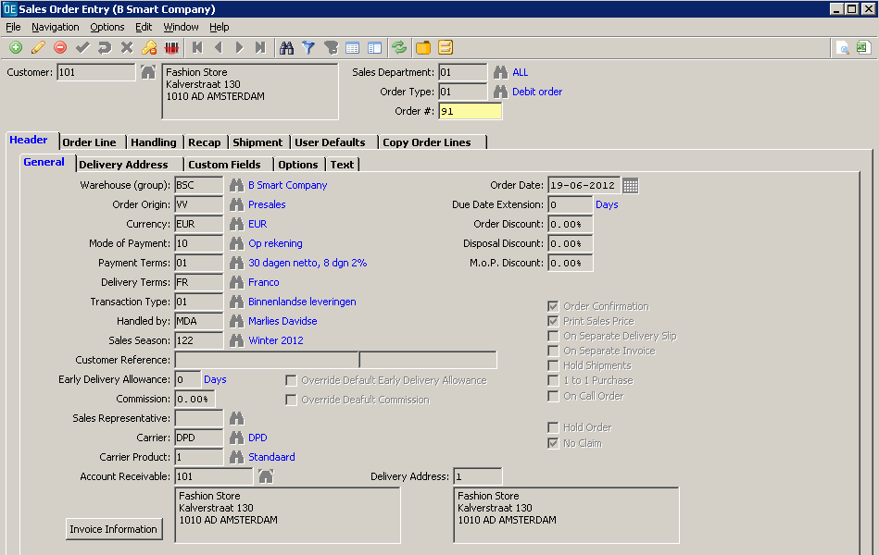

**Tab [Delivery Address]**

The standard delivery address of the customer will be shown. You can also choose for another address of the customer. If the address is not yet registered in the relation file, you can enter the address here. With the indication *Default Delivery Address* you can indicate that this new address should be the (default) address for future deliveries.

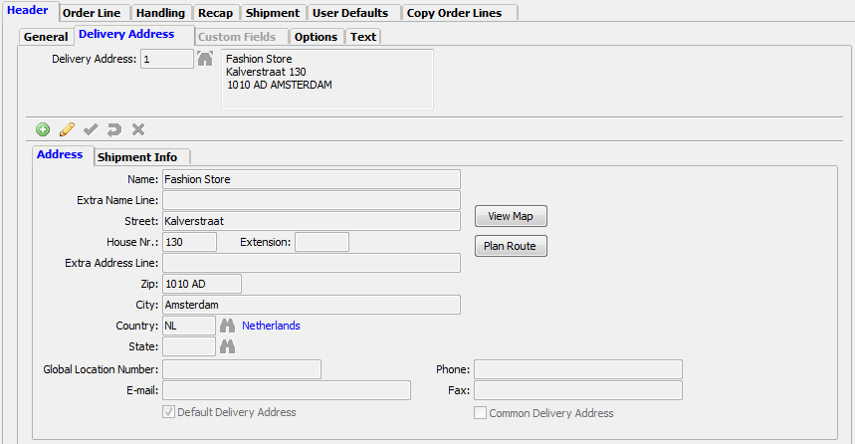

**Tab [Options]**

Here you find a number of functionalities to perform actions concerning the order. This concerns eg. generating a delivery slip, canceling an order or deleting an order. This will be explained further in the chapter ‘Specific functionalities’.

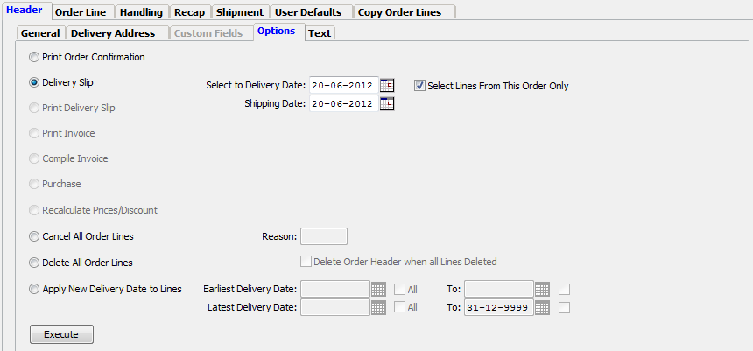

# SALES ORDER LINE

**Tab [Details]**

After entering the article number, you can enter the dimensions quality, color and/or assortment. If it does not concern an assortment, you can fill in the quantities per size in the block on the right. In that block an indication of the stock will be given. Which stock is shown depends on the order origin you chose in the order header. This way you can see the available stock for a direct delivery and the future stock for a presales order. Via parameter settings it is possible to show packaging information and the size according to a different size system in the block with stock information.

* Delivery period

The first date is important to indicate from which date delivery should take place. The second date is optional. You can use this in case you have agreed a specific delivery period with the customer. If that is not the case, you can keep the default date on 31-12-9999. This is important, because the delivery proposal can give a negative advice for delivery when the latest delivery date is passed.

* Sales price and discounts

The sales price and discounts are filled from master data. A specific price can be applicable for a customer, eg. due to a price agreement. If a specific price is not applicable, the price from the master data of the article will be shown.

You can adjust the sales price and the discounts manually by marking the indicator *Custom Price*. Even if you later change back the price to a ‘standard’ price, the indication for the line will remain ‘custom price’.

* Price fraction

A price fraction can be applicable for an article. The article can have different prices per size, per color or per quality. If the standard price does not have a price fraction, you can select a price fraction for the specific order. You need to mark the indicator *Price Fraction* and then select *Item Price Fraction* and/or *Size Group Price Fraction*. Within these the fraction is defined. These fraction need to exist before you can register prices per fraction on the order line.

If you have entered a price fraction, the system will show the average sales price in the field *Sales Price*. This is calculated evenly based on the price fraction.

* Price per

When you have activated this option, a field *Per* will become available next to the sales price on the order line. You can only adjust this indication after you have marked the indicator *Custom Price*. The default value is ‘1’. You can change this to 10, 100, 1000 or 10000. The option *Per* is also available on the tab [Prices] in the order matrix.

The price in multiple decimals is specifically applicable for calculating the gross order line value. The rounding is done after multiplying with the quantities. The gross order line value will always be registered in two decimals. The first discount which is applicable will be calculated over the gross order line value and will be stored with two decimals. The next discount will then be calculated over the gross order line value minus the (rounded) first discount value, etc.

It is possible that rounding differences will occur between the order confirmation and the final invoice. That could specifically be applicable with partial deliveries. Per delivery/invoicing the rounding will be applied. Adding these parts could lead to a difference with the original total.

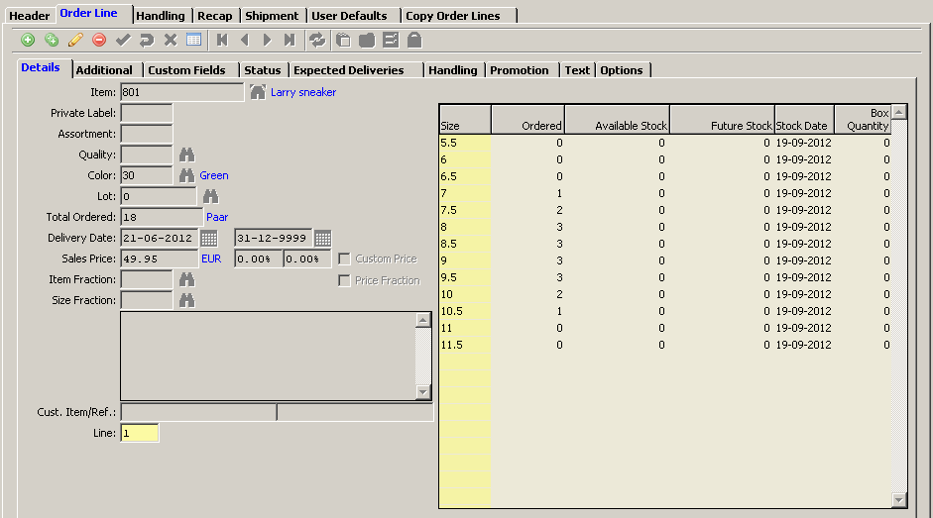

If the sales order is in another currency than the administrative currency, the standard sales price is determined in a specific way. The standard price in the article master data is always in the administrative currency. When you do not have a price structure for a price per currency, then the system will use the commercial exchange rate. Be aware that the financial exchange rate will NOT be used for this. If a commercial exchange rate is not found, the system will use zero, which means the sales price will become zero. The system will give a notification for this, so the user can take action to solve this.

**Order matrix**

By using the icon **Order Matrix Entry** in the toolbar of the order line () you have the possibility to enter the quantities per quality/color and per size quickly. By entering the article number and the button **Apply** the matrix will be activated. You can hide the stock columns by marking the indicator for that option. The window will be more structured without the stock information per column. The stock information is also shown at the bottom on the left.

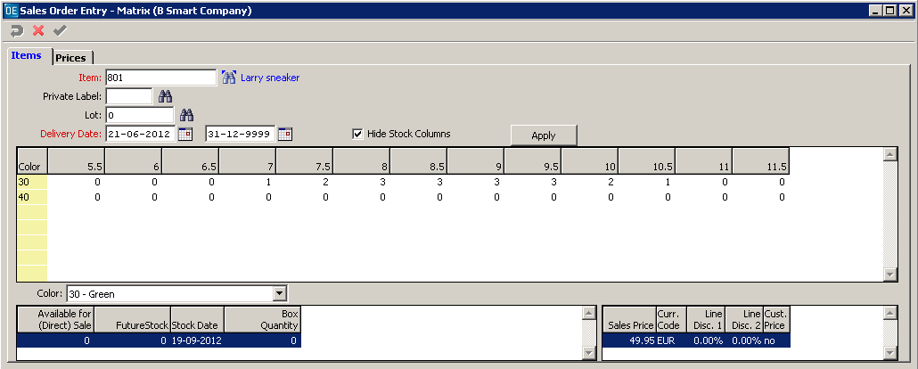

**Tab [Status] – Tab [Expected Deliveries]**

Here you will see an overview of the status of each order line entered. Under expected deliveries the expected delivery date and quantities are shown per order line.

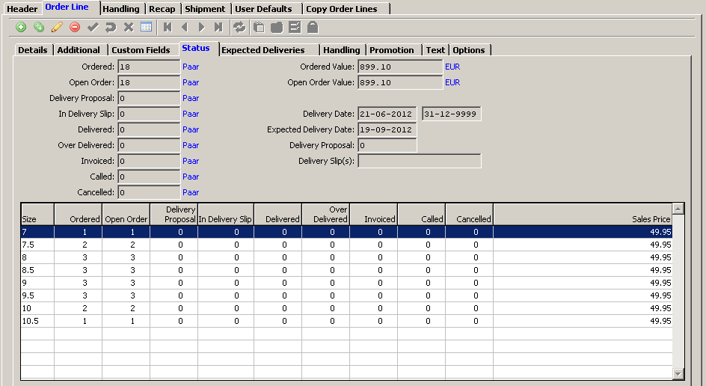

**Tab [Options]**

Here you find a few functionalities to perform actions concerning the order line. This concerns a.o. cancelling an order line or sizes.

# CHANGE ORDER

**Change order lines**

With the icon for **Modify Record** () you can change the order line. If the order line is already in a delivery proposal or a delivery slip, you cannot change the lines. You need to remove the order (lines) from the proposal or cancel the delivery slip before you can change the order line. It is also not possible to change an order for a blocked customer.

**Change order header**

If order lines are entered, you cannot change a number of fields in the order header. This concerns sales department, order type, warehouse and currency. If you want to modify one of those fields, you need to delete the order and enter it again.

When you already created a delivery proposal or a delivery slip for an order, you can modify fields in the order header. These adjustments only apply for the lines which are not yet in a proposal or on a delivery slip.

**Delete order or order line**

An order line can only be deleted as long as the order line(s) is not yet in a delivery proposal, delivery slip or invoice. In that case you cannot select the delete icon in the toolbar. A complete order – including all order lines – can be deleted via the tab [Options].

Consider that deleting means removing the order/lines from the file. Afterwards you cannot see if the entry has taken place. When you cancel an order/line these remain in the system.



# SPECIFIC FUNCTIONALITIES

## Freight charges and handling cost charges

You can calculate freight charges and handling cost charges for an order. For the freight charges this can go automatically via the delivery condition (indication *Charge Delivery Costs*) and the freight charges table. For the handling cost charges this can also go automatically. At the customer the indication *Handling Charges Allowed* must be active and you need to have filled the table for calculation of the handling charges. The tables for freight charges and handling cost charges are based on a steps form. Then it is possible that even though the table is applicable nothing will be charged. Eg. it is possible that you do not calculate charges for a value larger than eur 100,-.

In the order header you can see under the tab [Recap] if freight charges and/or handling cost charges are calculated. On the same tab you also see the order totals. On this tab you can modify the amounts for freight charges and handling cost charges. You can modify these, but also put these to zero and that way do not calculate any charges. To modify the charges you first need to indicate on the right that you want to overwrite the amount for freight charges or handling cost charges. Next you can enter an amount or a percentage on the left.

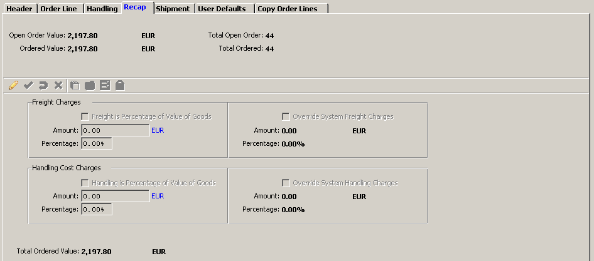

## Generate delivery slips

You can generate delivery slips via the delivery proposal or via the sales order. The latter will mainly be the case for direct orders. After you entered the order lines, you go to the order header and the tab [Options]. There you see the option to generate a delivery slip. As delivery date today is prefilled. This means that order lines with a later delivery date will not be selected for the delivery slip. You can change the selection for the delivery date and the shipping date on the tab.



There is also an option to select order lines from other sales orders for the delivery slip. By default this option is marked, so that only the lines from this order and not those from other orders will be included on the delivery slip. After you pressed the button **Execute**, the system will generate the delivery slip. The system will give a message for the result.

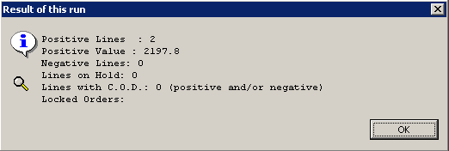

The system will not create a delivery slip immediately, but first a delivery proposal. This is a ‘general’ proposal. In the implementation data this proposal got a specific number (mostly ‘999999999’). The proposal will be shown (after **OK**). You get an overview of what is included in the proposal. You have the option to make changes.

From the proposal window you can create the delivery slip. You need to go to the tab [Customer Information]. Here you will also find information about any negative lines. If you want to deliver regardless the negative advice, you need to overrule these first with the button **Overrule All**.

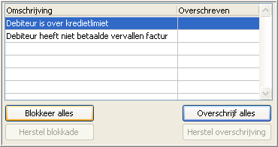

At the bottom on the right there is an option to generate the delivery slip. If there are negative options in the proposal, the option *Remove Negative Lines* will be active. You can unmark this, but this means that the negative lines will remain blocked in the proposal and cannot be delivered in any other proposal. You can only deliver it via the ‘general’ proposal where you need to go to separately afterwards.

You can also choose to remove all lines from the proposal. This way you undo your choice to generate a delivery slip. The order lines concerned will get the status ‘outstanding’ after that.

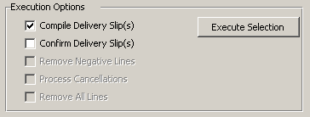

After the choice **Execute Selection** the delivery slip(s) is generated. If the printermanager is active, the delivery slip will be printed automatically. Otherwise you need to use the separate print program. If you work with the module WMS, you need to generate picktickets from the delivery slip(s).

If you did not choose to generate the delivery slip from the proposal and you have not deleted the lines from the proposal, the order lines will remain in the ‘general’ proposal. Generating the delivery slip(s) then needs to be done via the program **Compile Delivery Slips** (menu path: Sales | Delivery Proposal). In that program you select the ‘general’ proposal. In a separate window you can generate the delivery slip(s). You can select the order number if you only want delivery slips for your order and not for other orders. It is advisable to define an internal procedure for this.

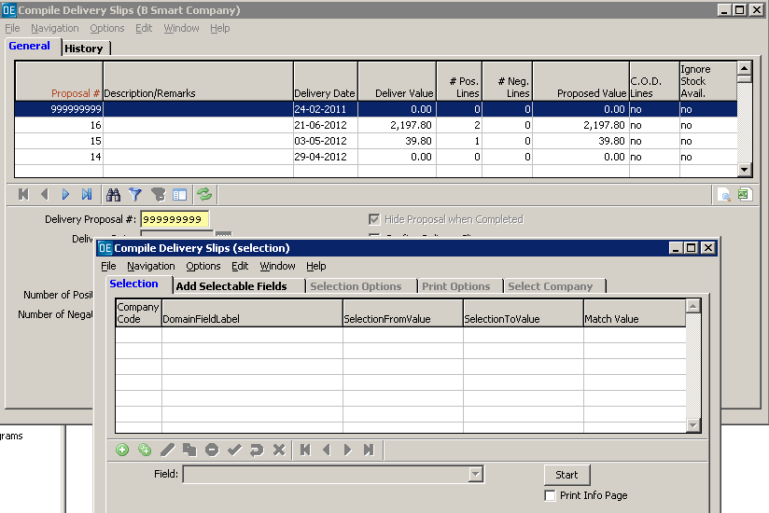

## Copy order lines

You can generate a sales order by copying lines from another order or from a delivery slip or from an invoice. Copying from an order can eg. be practical if a head office places orders for multiple branches for the same articles and quantities. Copying from an invoice can eg. be practical if you want to credit it (completely). The functionality for copying can be found under the tab [Copy Order Lines].

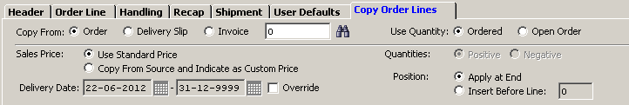

Most of the times it is practical to generate an order header first and then copy the lines. In the example for the order copy you want to select another customer. In the example of the credit note you need to indicate another order type in the order header. You cannot modify that when lines are in the order.

For copying you choose *Order*, *Delivery Slip* or *Invoice*. Next you can enter the number from which you want to copy. You can use the lookup for that. Lines which apply to the selection will be shown on the screen. These will be selected automatically (marker in front of the line).

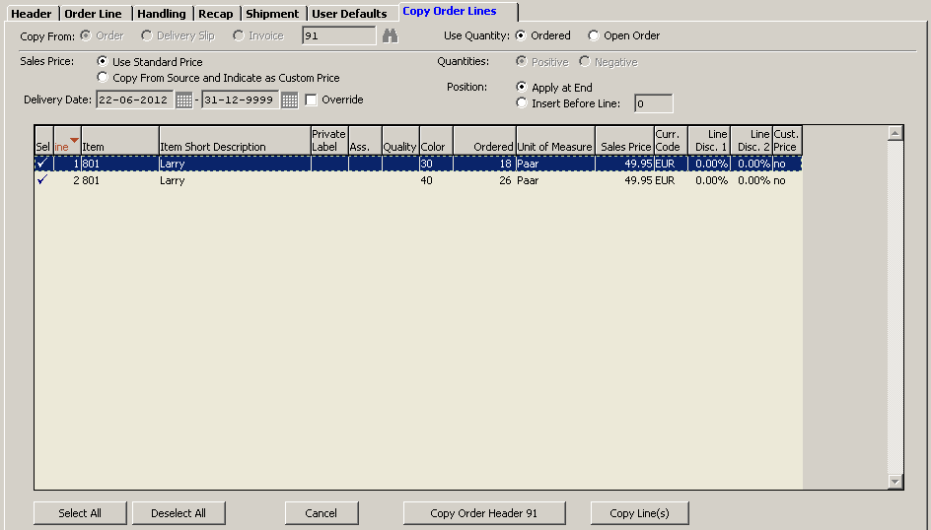

For copying from an order you can indicate if you want to use the ordered quantity for copying or only the open order quantity (indication at *Use Quantity*). For copying from a delivery slip the choice is between delivered quantity or planned (to deliver) quantity.

For sales prices you can indicate if you want to apply the standard price. This is the default option. This means that the system will determine the price which is applicable for the customer concerned. This can be another price or a price agreement. You can also choose to copy the sales price from the source. In that case the price is taken from the order, delivery slip or invoice from which you are copying. The price will then also be marked as ‘custom price’ even if is the same as the standard price.

Furthermore you have the possibility to modify the delivery date of the lines to copy. Otherwise the delivery period is taken from the order, delivery slip or invoice from which you are copying.

The option Position is mainly meant if you are copying lines into an existing order. In that case you can indicate if the lines should be added at the end or before a specific line.

The choice for *Equal* or *Reversed* at *Quantities* for the lines to copy depends on the order type in the order header. Under the order type you can indicate if eg. also negative quantities can be entered. The choice also depends on the source from which you copy. The indication *Equal* or *Reversed* also relates to the possibility that an order can have both positive and negative quantities. At *Equal* the positive quantities will remain positive and the negative quantities will remain negative.

Per line you can activate or de-activate the selection. You can also use the buttons **Select All** and **Deselect All**. The button **Copy Order Header** in fact is only applicable if you have not generated an order header up front. You can do this from the copy functionality. As there can be multiple orders to be copied, you first need to select the line from which you want to copy the order header (by default it will be the first line). That is the order header from the original order, delivery slip or invoice. Be aware that you cannot change certain fields in the order header after you have copied order lines (a.o. order type, warehouse and currency). With the button Copy Line(s) the copy action will be executed.

On executing the copy action the system will ask for a confirmation. With that question the system also indicated under which currency the order lines from the original order are entered. This is specifically important when you have indicated that the sales prices need to be copied from the source. That can have undesired consequences.

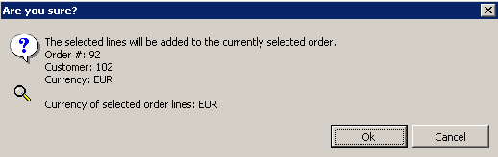

Of course you can make changes in the order lines after copying.

## Generate sales order from purchase order

Menu: Purchase | Purchase Basics | Create Sales Order From Purchase Order

When there is a company within your concern that buys goods from another company, it would be double work to enter that purchase order as a sales order in the other company. You can use a separate program for this. It is only applicable for companies that are in the same database in XL‑ENZ. This can be applicable for compannies that do not work with a distribution center, because then this is arranged via that module. Of course this copy can only be done when the item file is shared.

The program is only a tool for generating the sales order. The information from the purchase order in the company in which the program is started, will be copied. A connection between the purchase order and the sales order is not maintained. It is also not registered whether this action has previously been done.

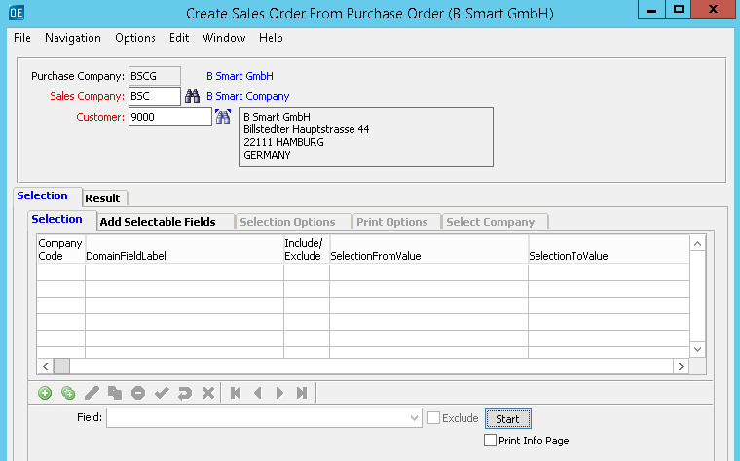

You indicate to which company and which customer in that company the purchase order should be copied. We advise you to enter a selection.

The system will use the default user values from the user that performs the copy action in the company to which is copied. When these are not filled or only partially, a message will follow and the copy action cannot be completed. Be aware of the warehouse code in the default values of the sales order.

When the copy action is successfull, the system will show on the tab [Result] from which purchase order which sales order is created.

In the sales order header the currency code of the purchase order is filled. Furthermore the items with the quantities are filled on the lines. The ETA will be taken as requested delivery date. The sales price will not be taken from the purchase order. This is determined from the pricing structure or the base price is applicable.

## Global update earliest delivery date

Menu: Sales | Sales Basics | Earliest Delivery Date Global Update

There is a separate program, with which you can update the earliest delivery date for a range of sales orders. That is the delivery date requested by the customer. Be aware on entering the selections, because the delivery dates will be overwritten and you can not undo this. The original date will not be kept.

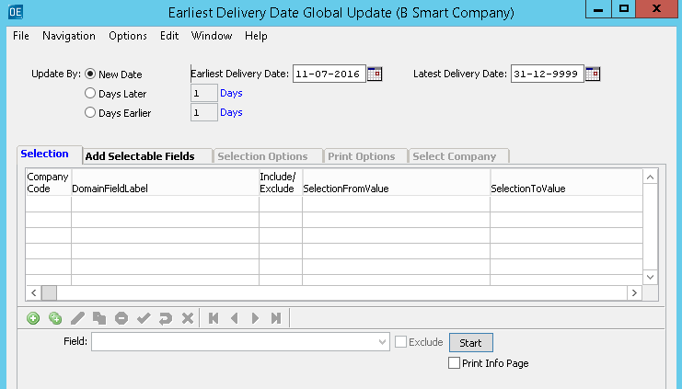

## Cancellation of Order Line(s) (sizes)

Menu: Sales | Sales Basics | Cancellation of Order Line(s) (sizes)

In XL-ENZ it is possible to cancel order lines in several different places. This can be done from the sales order or from the delivery proposal, but also via a separate batch program. This program allows you to cancel multiple order lines at once, this may apply if a particular item is not put into production and this item has been entered into multiple sales orders.

In this program you must enter a sales cancellation reason, after that it is important to enter the correct selections so that the correct order lines will be cancelled. Please note that if you do not enter a selection here, all open sales order lines will be cancelled.

# CUSTOMER SERVICE COCKPIT

Menu path: Sales | Sales Basics | Customer Service Cockpit

The Customer Service Cockpit is a functionality that combines sales information with sales order entry. It is specifically meant for the Customer Service department to quickly give information to a customer and immediately enter an order. Due to this concept only a limited set of data is used compared to the ‘standard’ sales order entry. Because of this limited set of data an order can be entered more quickly. Regarding the sales information the setup is that the information is mainly ‘focussed’. Furthermore the functionality is setup so it can be (almost) completely navigated with the keyboard (no mouse).

**Tab [General]**

This concerns the order entry, where also a number of information components are available, like article information, pictures, customer information and stock information. The concept is that in the entry segment (bottom part) all dimensions of the article are shown. The sizes will be shown as separate lines.

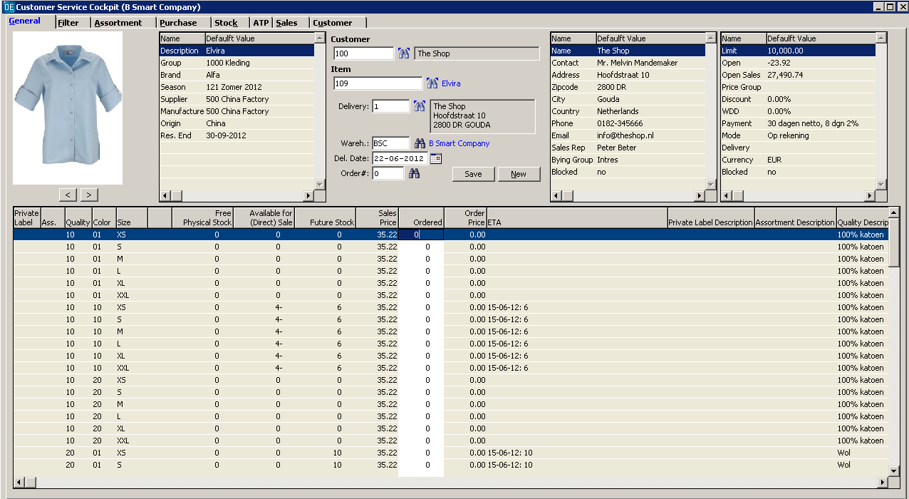

After entry of the customer and the article the focus will go to entry of the quantities. The warehouse code is default empty. This means that the stock shown will be of all warehouses. If a warehouse is selected, the stock of that warehouse will be shown. On saving the order the warehouse from the user defaults will be used.

In front of the customer, the item number and the order there is a ‘T’, which indicates that you have the option to enter text. When you have not defined text codes, this option is not selectable. When a text is present, the ‘T’ will be blue. Otherwise it will be black.

Related to the manual entry there are a number of shortcut keys defined for actions:

F2 – save order;  
F3 – switch to tab [Filter] (and back);  
I – to item/article number (from browse);  
C – to customer (from browse);  
W – to warehouse (from browse);  
O – to order number (from browse);  
D – to delivery address (from browse);  
alt+N – new order;  
alt+F – to tab [Filter];  
alt+A – to tab [Assortiment];  
alt+P – to tab [Purchase];  
alt+K – to tab [Stock];  
alt+T – to tab [ATP];  
alt+S – to tab [Sales];  
alt+U – to tab [Customer].

An exclamation mark at outstanding invoices means that there is at least one invoice overdue. Double click in that box with financial information will start a separate window with information about outstanding invoices of the account receivable.

The combination of the ALT-key with a letter to switch tabs is applicable for each tab. On each tab you can use F5 to refresh the information.

**Tab [Filter]**

This component contains a number of search options. The user can also use a combination of search options. The articles found can be selected. The article selected will be shown on the tab [General]. The filter will remain until you enter a new filter. This way you can switch screens and select different articles. With the arrow keys you can walk through the filtered articles. With <enter> you can select an article. Entry based on the indicator *Matches* can be done without a wildcard.

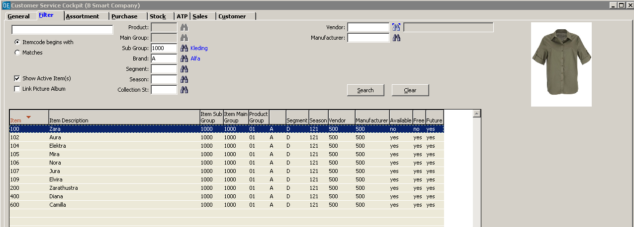

**Tab [Assortment]**

This tab shows information concerning the composition of the assortment. This concerns the dimension which is active on the tab [General] at that moment. An assortment is one of the dimensions of an article.

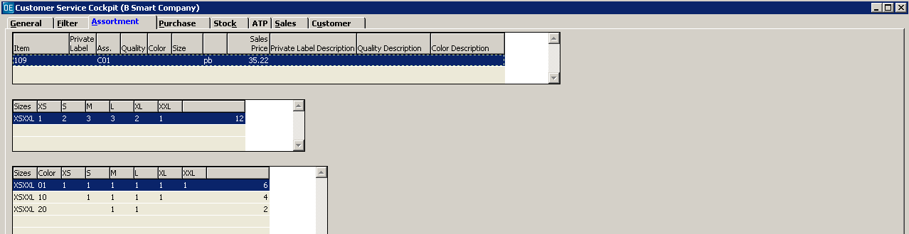

**Tab [Purchase]**

On this tab information is shown concerning outstanding purchase order lines of the dimension which is active on the tab [General] at that moment. That can eg. be a specific size or an assortment. The information is split in a general part which contains information of the article and a part with information about the purchase order lines. A separate block shows information about lines in transit.

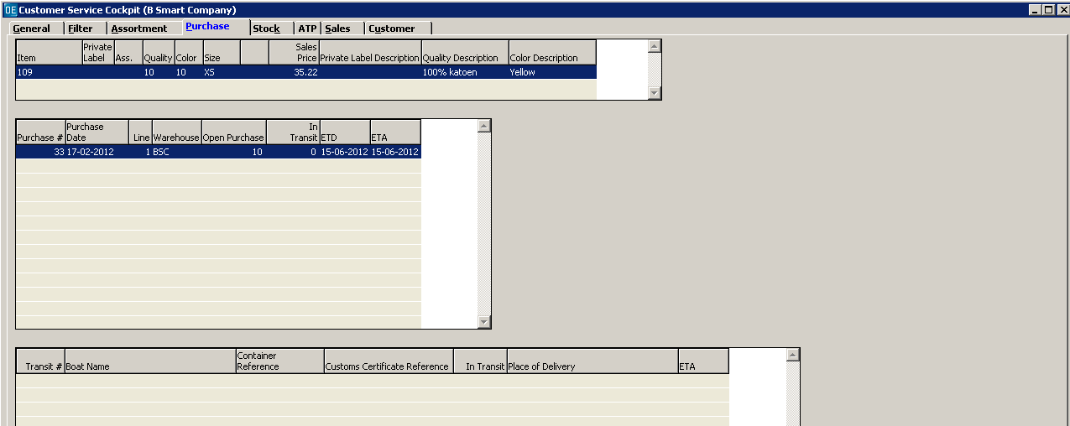

**Tab [Stock]**

On this tab information is shown concerning the stock of the dimension which is active on the tab [General] at that moment. That can eg. be a specific size or an assortment. The information is split in a general part which contains information of the article and a part with information about the stock. This concerns the physical stock, the free physical stock, the available stock and the future stock. The ATP stock (separate module) is shown on a separate tab.

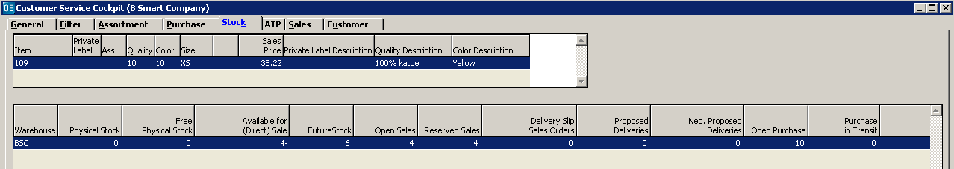

**Tab [Sales]**

On this tab information is shown concerning the outstanding sales orders of the dimension which is active on the tab [General] at that moment. That can eg. be a specific size or an assortment. The information is split in a general part which contains information of the article and a part with information about the sales order lines. This concerns the outstanding sales order lines of the selected dimension concerning all customers.

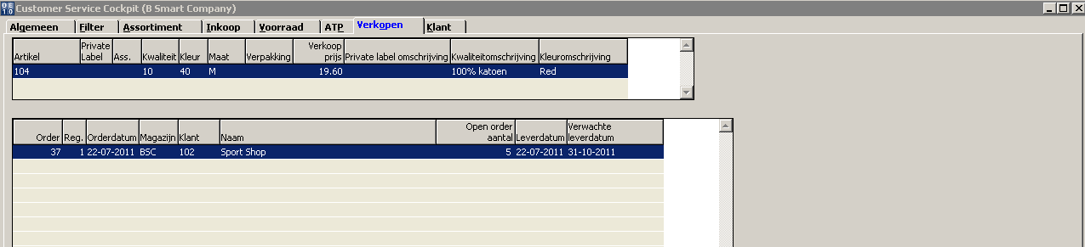

**Tab [ATP]**

On this tab information is shown concerning the ATP stock positions (separate module) of the dimension which is active on the tab [General] at that moment. That can eg. be a specific size or an assortment. The information is split in a general part which contains information of the article and a part with information about the ATP stock positions. As elsewhere in XL‑ENZ the ATP stock positions are shown per date of availability.

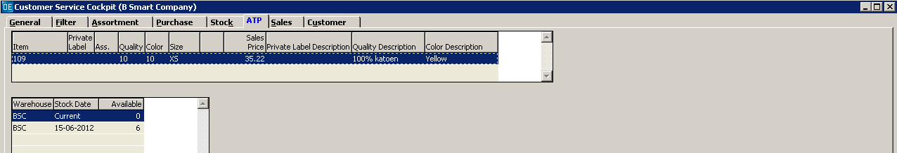

**Tab [Customer]**

On this tab information is shown concerning the outstanding sales order lines of the customer. That concerns all outstanding order lines of that customer and is independent if the article is active at that moment on the tab [General]. A separate block shown additional information about the selected sales order line on this tab concerning the status of the delivery.

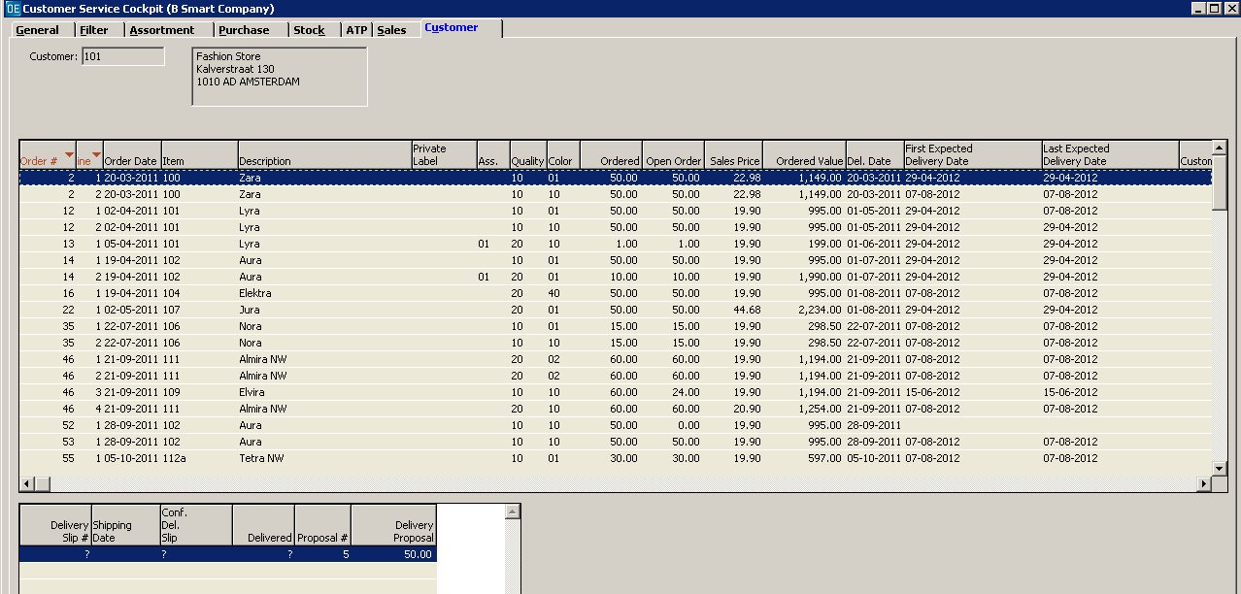

**Tab [Sales Price]**

On the tab [Sales Price] you can adjust the sales price or enter a discount percentage. When the price is adjusted to the requested price, you can process this via the button **Apply**. This step is necessary because the prices are also shown on the first screen and need to be updated. The adjustment will be applicable to all dimensions of the selected item on the tab [General].

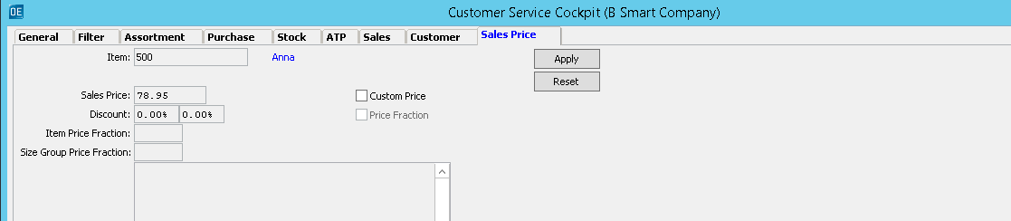

**Sales order header**

When an order line is saved and an order is created, you can start up a short version of the order header via the field **Order #**. You will see that the cursor changes in a small hand when you hover the mouse over it.

cid:image006.png@01CE0520.B97E7D50

A separate screen is started in which you will see the tabs with general order header information, custom fields and recap (to optionally enter freight and administration charges) and the options for the order header. Via the tab [Options] you have the possibility to generate a delivery slip or change the delivery date for the whole order.