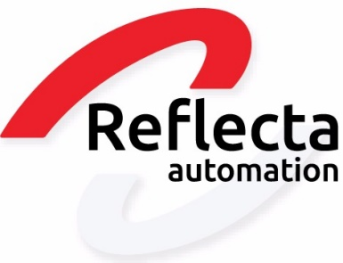
HELPDESK PORTAL MANUAL

Creating and Checking Tickets.
A Knowledge Base with Solutions.

You receive this manual on behalf of Reflecta.

ABOUT THIS MANUAL

Your data

Check your data
You will receive an email from us to create an account for the portal. After creating an account, it's important to verify if your data is still up-to-date.

Guide
In this manual, you will learn how to create a ticket in the portal, check the status of a ticket, and how to resolve issues using knowledge items.

Who is this manual for?
This manual is intended for:
- Customers using the XL-ENZ package.
- Customers receiving support from Reflecta Services.

Read the manual!
We recommend reading the manual thoroughly. This will enable you to use our portal correctly, allowing us to support you more efficiently.
CREATING AN ACCOUNT

You can create an account through the link provided in the email we sent you.
You open the email we have sent to you. In it, there is a link that will then lead you to the portal.

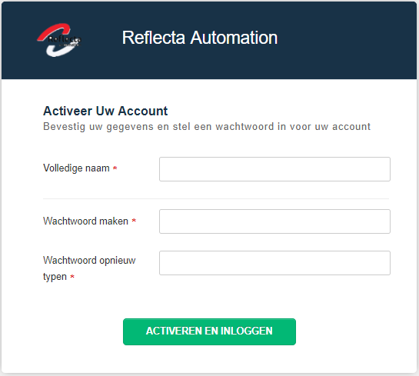

Then, you can activate your account by providing your full name and password. After activation, you will be automatically directed to our portal. (https://support.reflecta.nl/)

Login

Logging in to the online portal

Go to https://support.reflecta.nl/ via a web browser. Click on "Login" in the upper right corner of the screen.
Enter your details and click "Login." You now have access to the portal.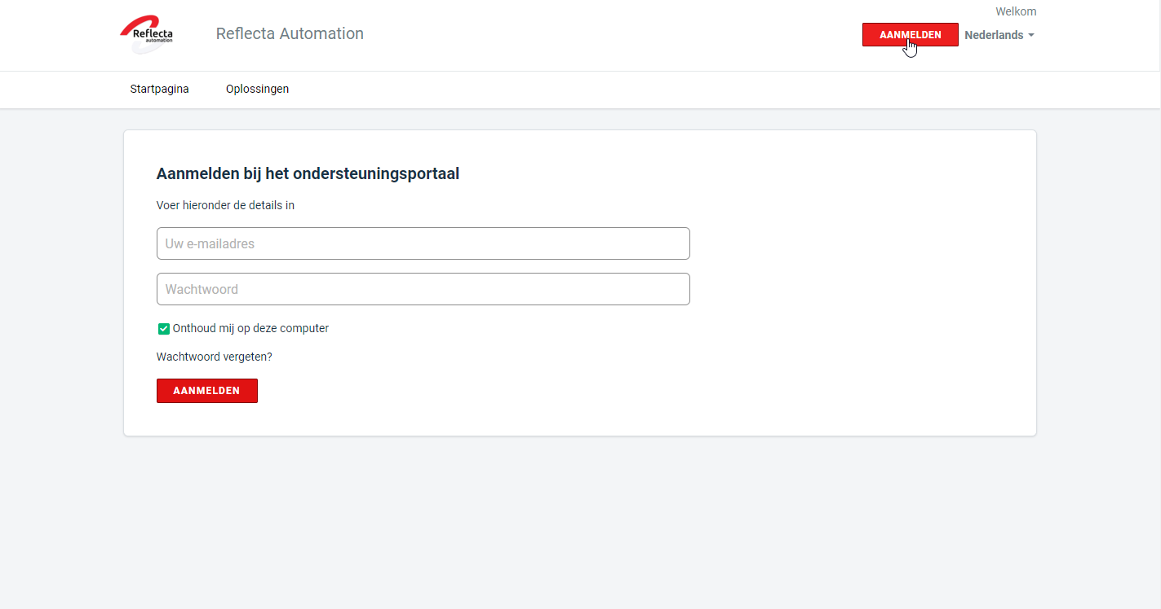

Ticket aanmaken
Creating a ticket

Creating a ticket on the online portal.

Log in to the online portal. Go to the 'Tickets' section, and then click on 'New Support Ticket,' or click directly on 'New Support Ticket' on the homepage

.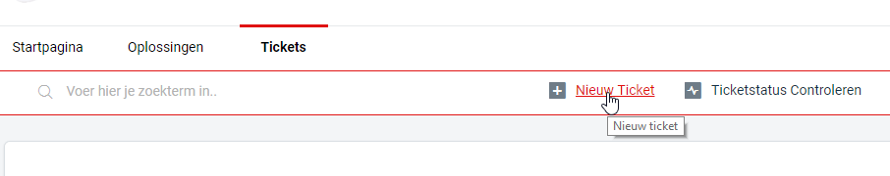

A ticket form will be displayed.
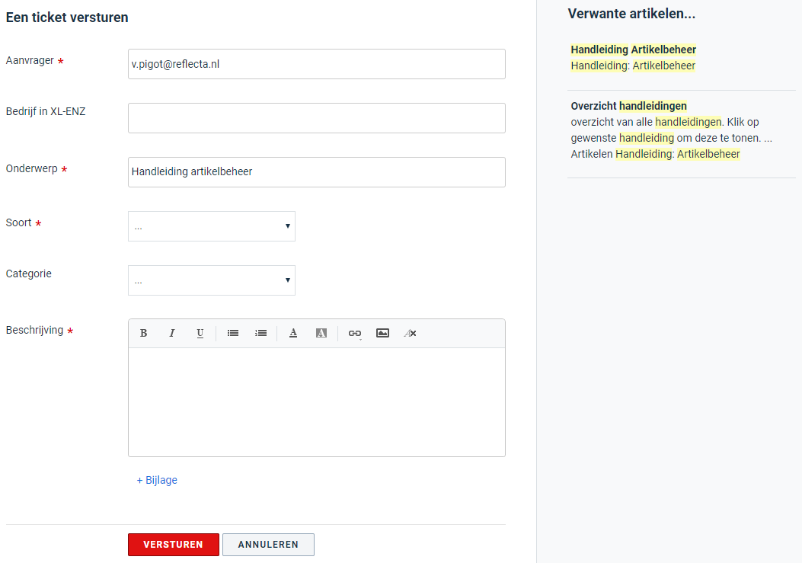

Requester: This field is automatically filled in once you are logged in. You will receive status updates and responses at the email address provided.

Company in XL-ENZ: This field allows you to specify the company you are logged in with in XL-ENZ. Having this information allows us to work more quickly and efficiently, so it's important to fill it in.

Topic: Provide a short but clear title that includes important information. For example, the order number if there is an issue with it. When you fill in the subject, the system will show related articles that might offer a solution. In this case, entering "Article Management Manual" in the subject field will display the article management guide.

Type: This field indicates the type of ticket you are submitting. It can be an Incident, Question, or Request. It's important to choose the correct type so that the ticket reaches the appropriate department, and we can assist you more effectively.

Category: You can specify the category your ticket falls under, such as XL-ENZ, Interfaces, Reports, Technical Maintenance, Other, or New UI.

Description: Here, you can add a description of your ticket. Include important information so that we can get to work promptly. Think of order numbers, invoice numbers, customer names, etc.

Attach a file: Finally, you can add an attachment. This can provide valuable information for us. A screenshot of an error message, for example, can be very useful for a ticket.

Checking ticket status on the online portal.

etstatus controleren

Checking ticket status on the online portal.

Log in to the online portal. Go to the 'Tickets' section, and then click on 'Check Ticket Status,' or click directly on 'Check Ticket Status' on the homepage.
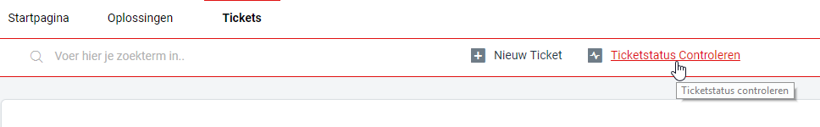
The ticket status page will be displayed. It shows all your tickets and their current status.
If you need to provide additional information, close a ticket, add a person to the ticket, or edit the ticket details, click on the desired ticket and perform these actions.
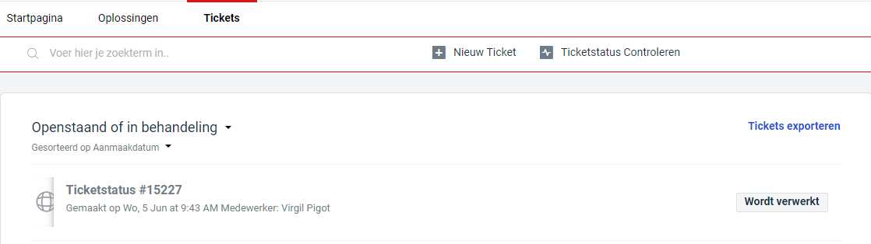

Accessing knowledgebase items.

Accessing knowledgebase items.

Log in to the online portal. Go to the 'Solutions' section.
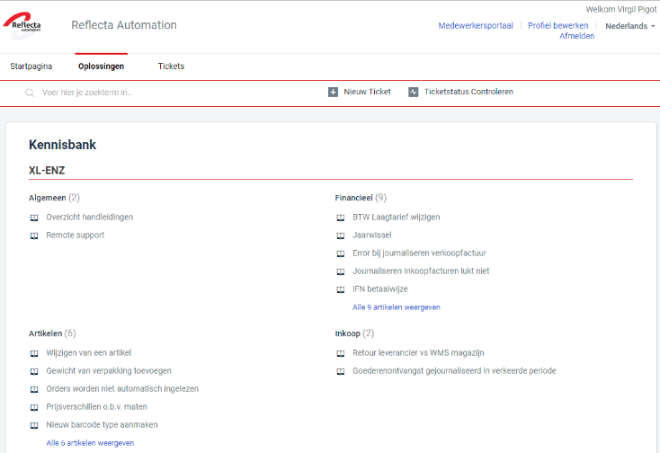
This page displays all available solutions. You can then choose a solution that you believe might be useful for the issue you're experiencing.

